Task-1:
• No Boot Device Found
- Issue: Hard drive/SSD is disconnected, broken, or the BIOS boot order is wrong.
• CMOS Checksum Error
- Issue: The small coin battery on the motherboard is dead and lost your BIOS settings.
• CPU Fan Error
- Issue: The processor fan is not plugged in, stopped spinning, or broken.
• Memory Failure / No RAM Detected
- Issue: RAM stick is loose, dirty, or dead.
• Keyboard Not Found
- Issue: Keyboard is unplugged, plugged into a bad USB port, or broken.

Task-2:

3 beeps on an AMI BIOS means a RAM (system memory) error. The PC cannot read the memory properly, so it stops and shows no picture on the screen.
Troubleshooting Steps
- Reseat the RAM: Turn off the PC, unplug it, open the case, take out the RAM stick(s), and push them back in tightly until they click.
- Test one RAM stick at a time: If you have multiple RAM sticks, remove all of them except one. Try turning on the PC with each stick individually to find if one stick is broken.

Task-3:
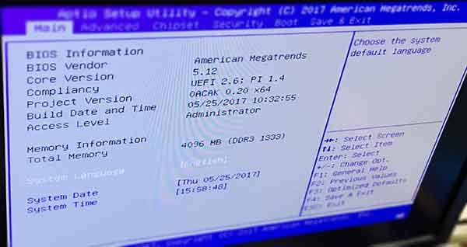
- Motherboard / BIOS Vendor: American Megatrends (AMI)
- BIOS Version (Core Version): 5.12 (UEFI 2.6)

Task-4:
The small battery on your motherboard is dead or low on power. Because of this, the PC lost its saved settings (like time and date) and loaded the basic factory settings instead.

How to Fix It
- Change the CMOS Battery: Turn off the PC, open the case, and replace the small CR2032 coin battery on the motherboard with a new one.
- Reset the BIOS Settings: Turn on the PC, press the key to enter the BIOS menu (like F2 or DEL), set the correct date and time, then save and exit.

